Title

Presenting Author¹, Co-author 1², Co-author 2³ and Co-author 3¹
Corresponding author: email.email@email.email
¹affiliation 1, e.g. Karlstad University, SE 65188 Karlstad, Sweden, ²affiliation 2, e.g., Umea University, SE 90187 Umea, Sweden and ³ affiliation 3, e.g., Domsjo Fabriker, SE 12345 Domsjo, Sweden

Normal text, figures and tables in an extended abstract (< 4 pages with title and references). Calibri (11 pts)
Table 1. Text (Calibri 10 pts)…

Continued Normal text (Calibri 11 pts)

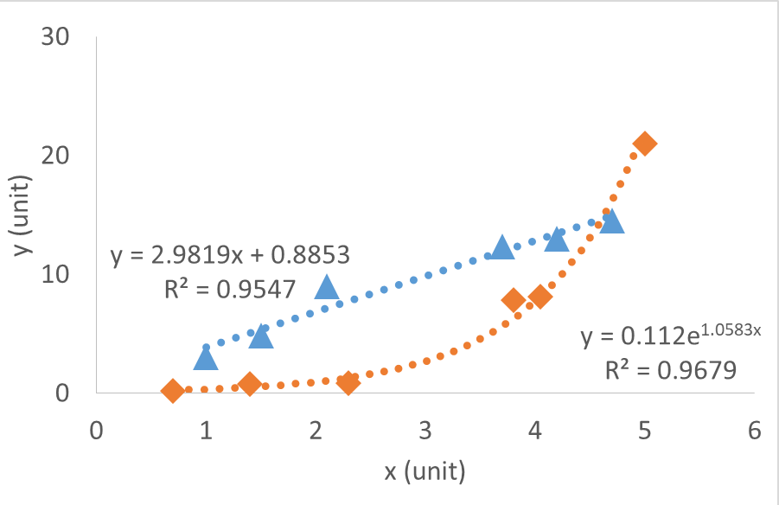
Fig 1. THIS IS AN EXAMPLE ONLY. TO BE USED AS A GUIDELINE! “Data A is represented by blue triangles and data b by orange diamonds (unit) as a function of x (unit). The dashed lines are modelled according to XYX (ref?)”. (The plots should not contain any “connecting the lines”, but lines should preferably be reserved to models.) Figure text: Calibri 10 pts. The numbers must be readable in the figure too.

Continued normal text (Calibri 11 pts)

Literature
References should be given as in the journal “Cellulose”

